ODD POSITION

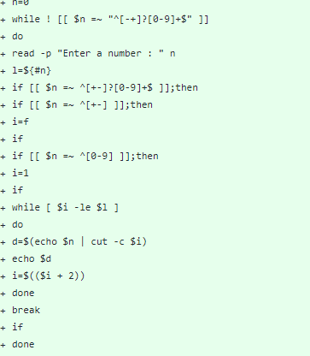

OUTPUT

